**SQA Advanced Diploma in Computing Software development**



**Usability Test Document**

**HP2N 47 – Software Development: Developing Small Scale Standalone Applications**

**Candidate Name: Nikhilesh Kovvuri**

**SCN No.: 207066915**

**Pre Usability Questionnaire**

1. Name
2. What is your Age ?
3. Are you beginner, intermittent or experienced user?

**Post Usability Questionnaire**

1. How would you describe the access of drawing of Paint app on the scale of 1 to 5.
2. how do you describe the rating for customizing brush size
3. Is the design of app easy to use ?
4. What was your overall impression of the app?
5. What feature do you find outstanding in this app ?
6. Is there any area where you feel there should be improvements ?

**Questionnaire form Screenshot**

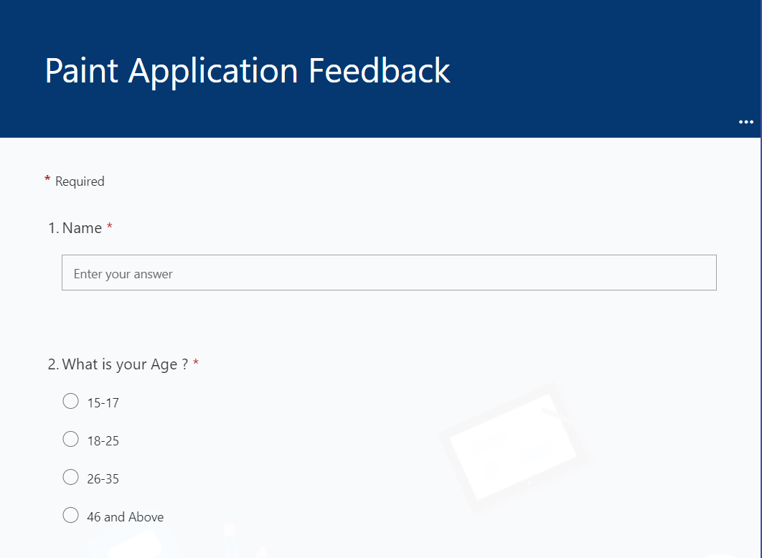

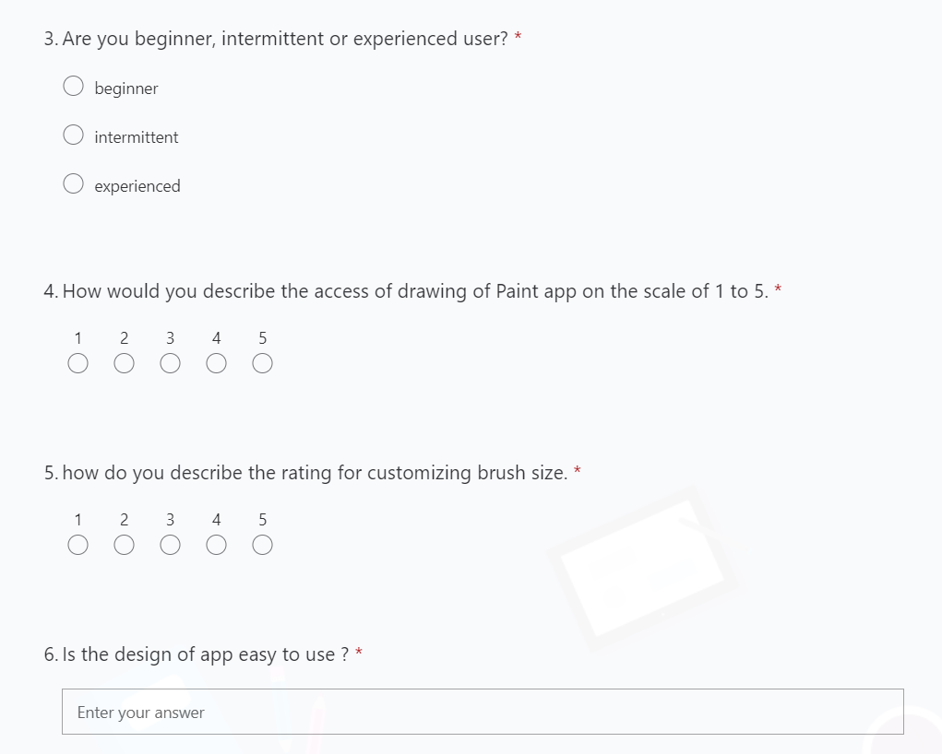

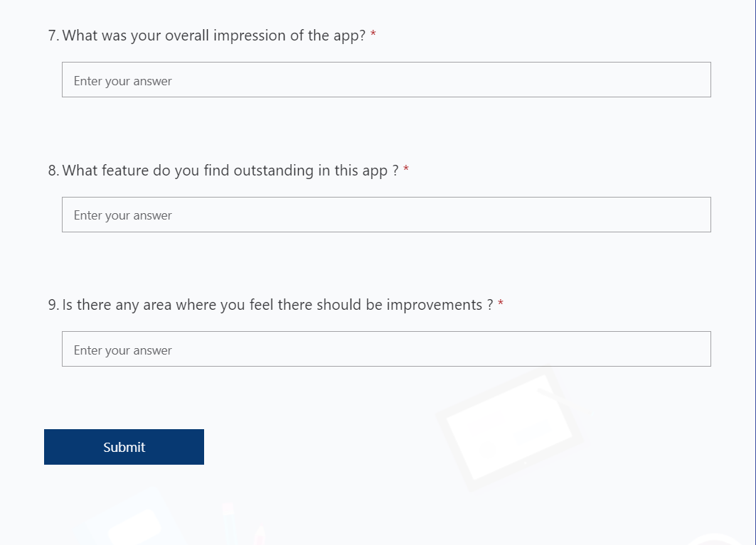

**Questionnaire form Response Screenshot**

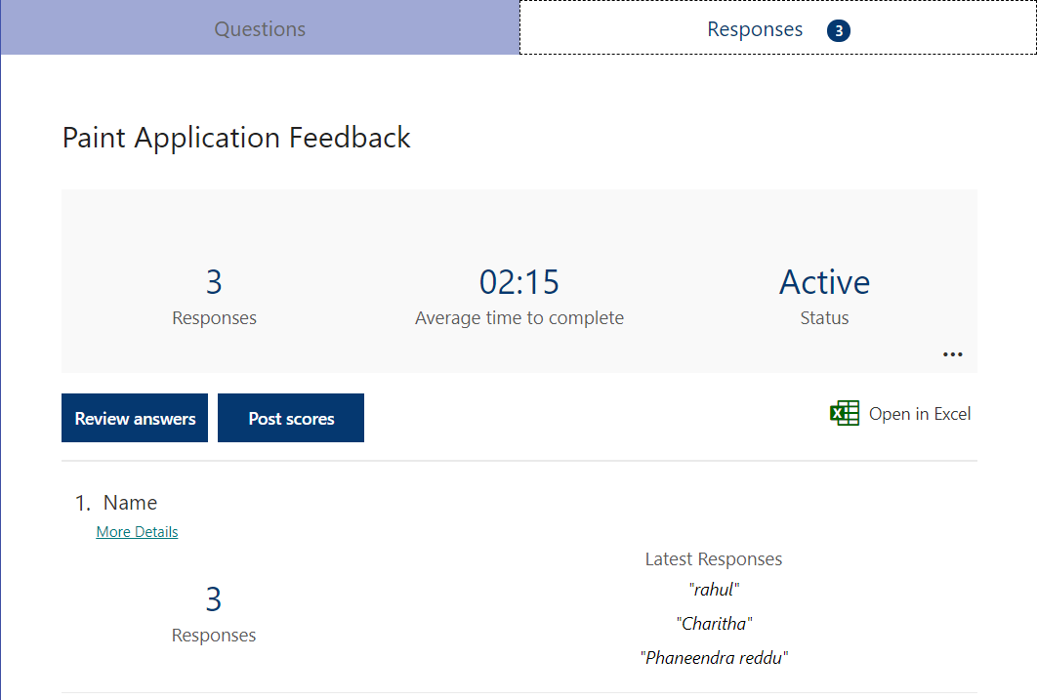

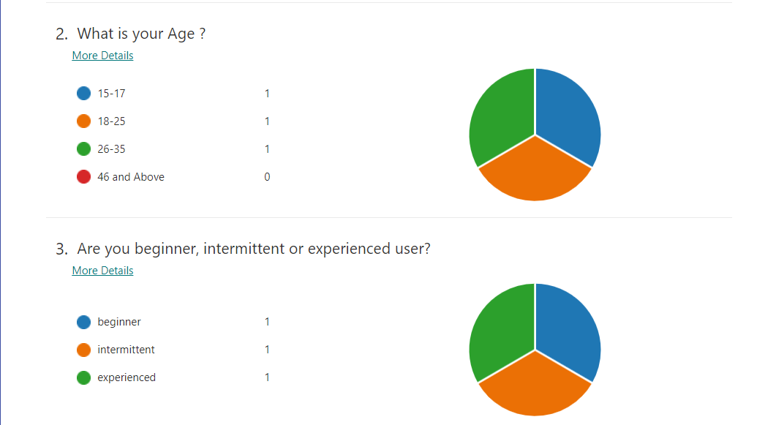

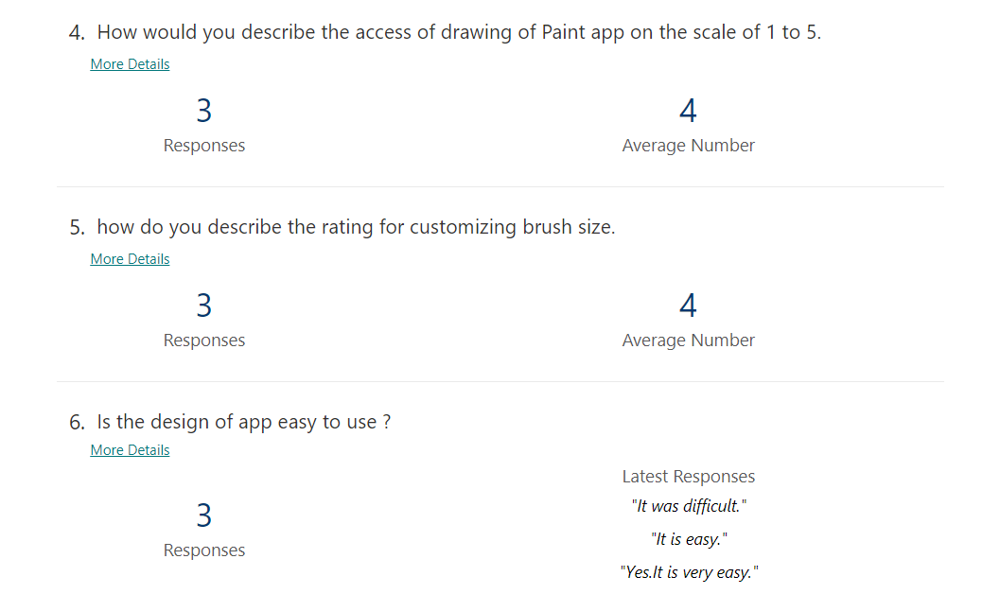

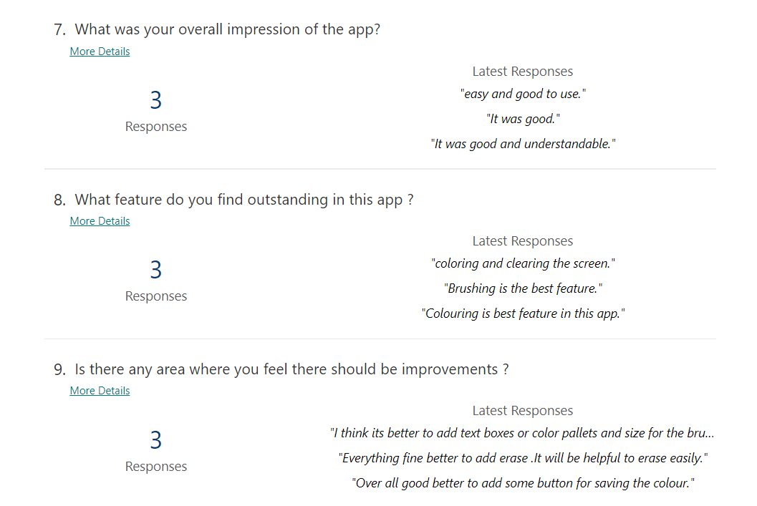**Form Link** - https://forms.office.com/r/bCnZyYZKHE